TCP/IP Principles and Protocols ( Week1)

Activities

Create a new project named GNS3-Intro-<studentid>, replacing with your actual student ID number, e.g., GNS-Intro-12345678.

------ Here is a new project named GNS3-Intro-12291447
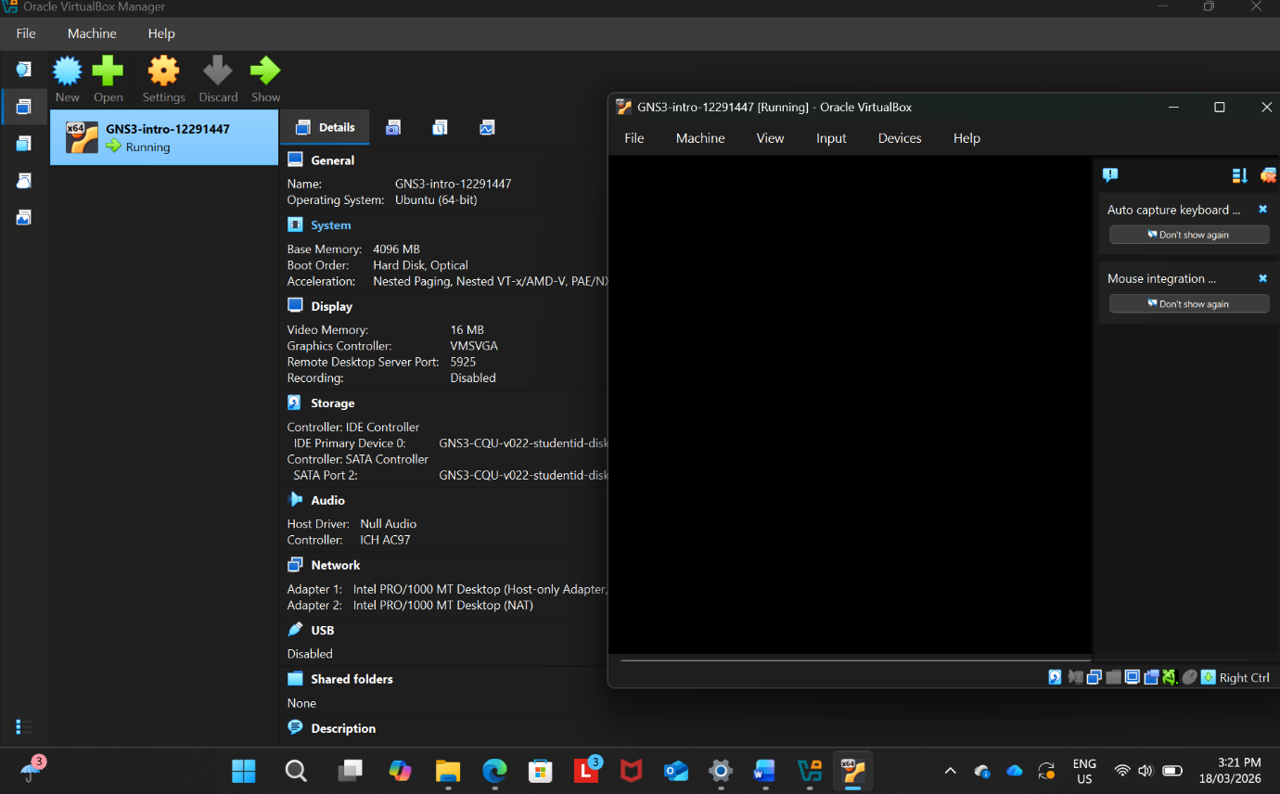

Add a single Linux Host node
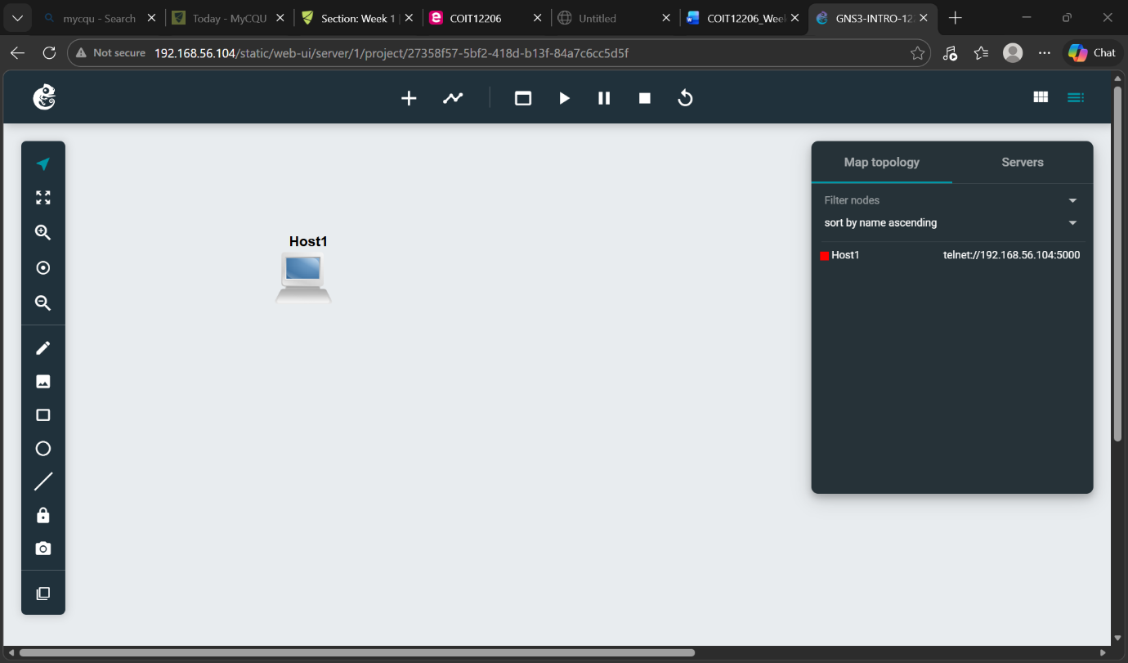

Add text showing the project title, your name, student ID and date (and optionally other useful information, e.g., unit code, campus, teacher)

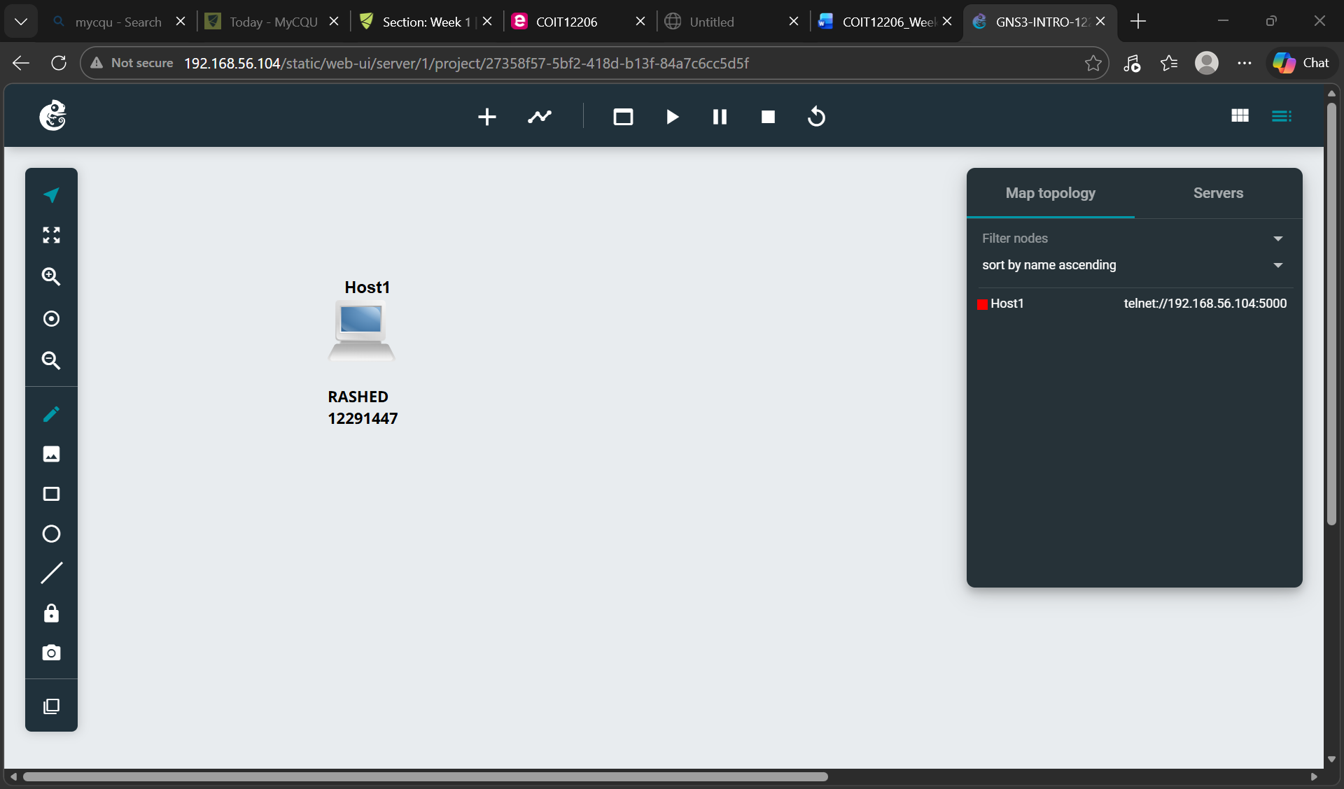

4. Select an IP address to use (e.g., 10.10.1.1). Your teacher may advise you to use a specific IP address.

5. Add text near the node showing the IP address.

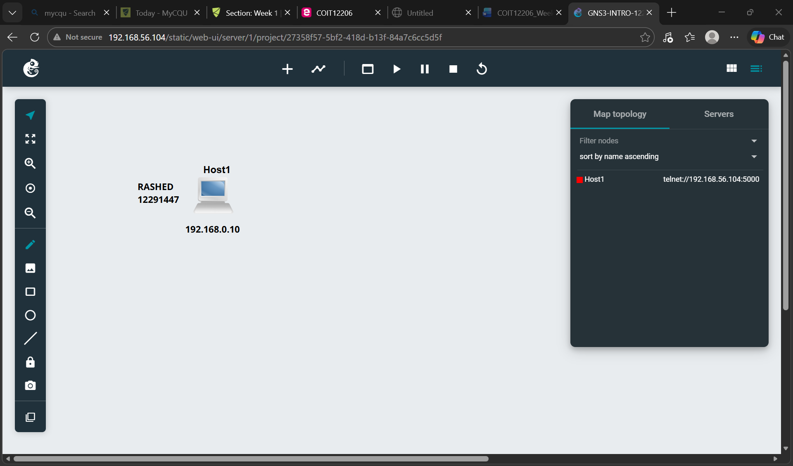

6. Configure the node to use a static IP address using the /etc/network/interfaces file. This must be done before the node starts.

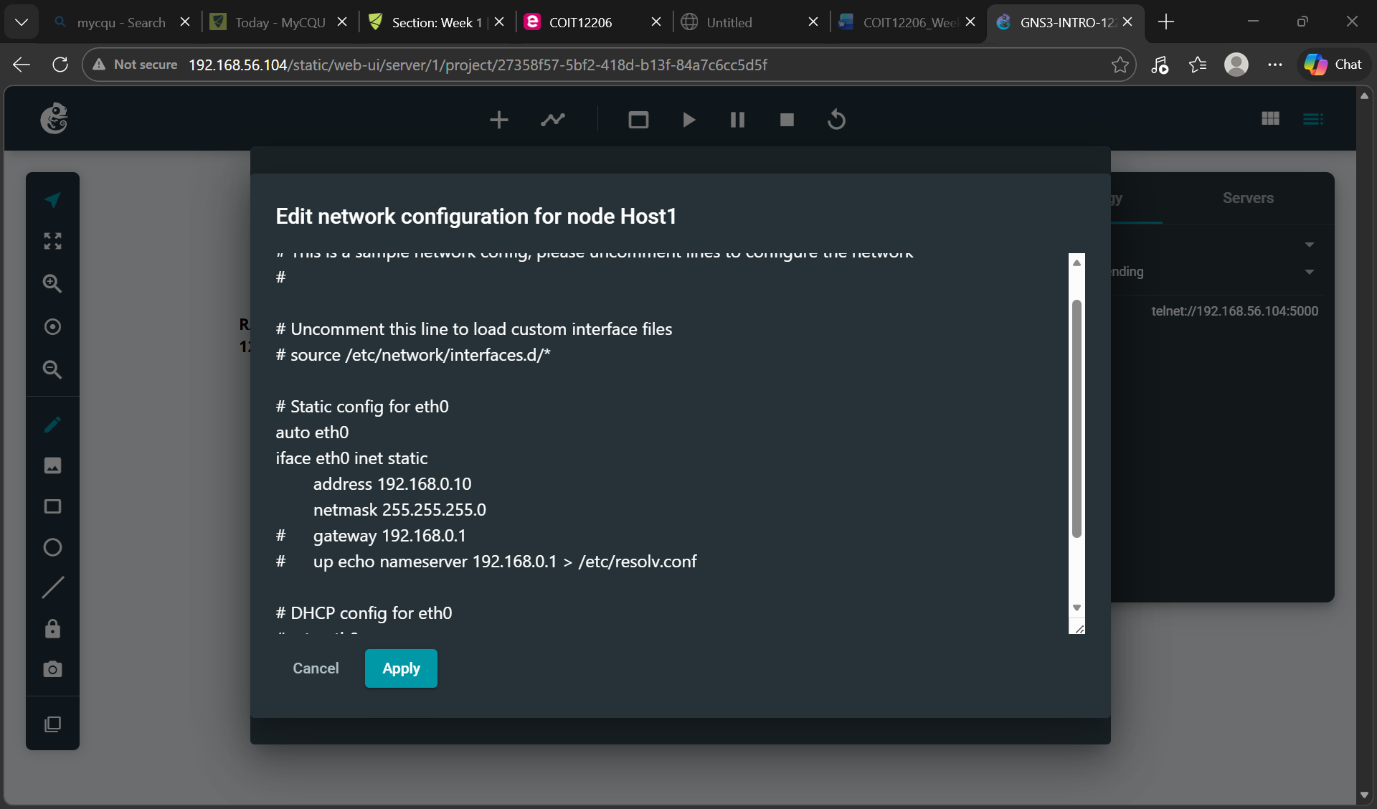

7. Start the node.

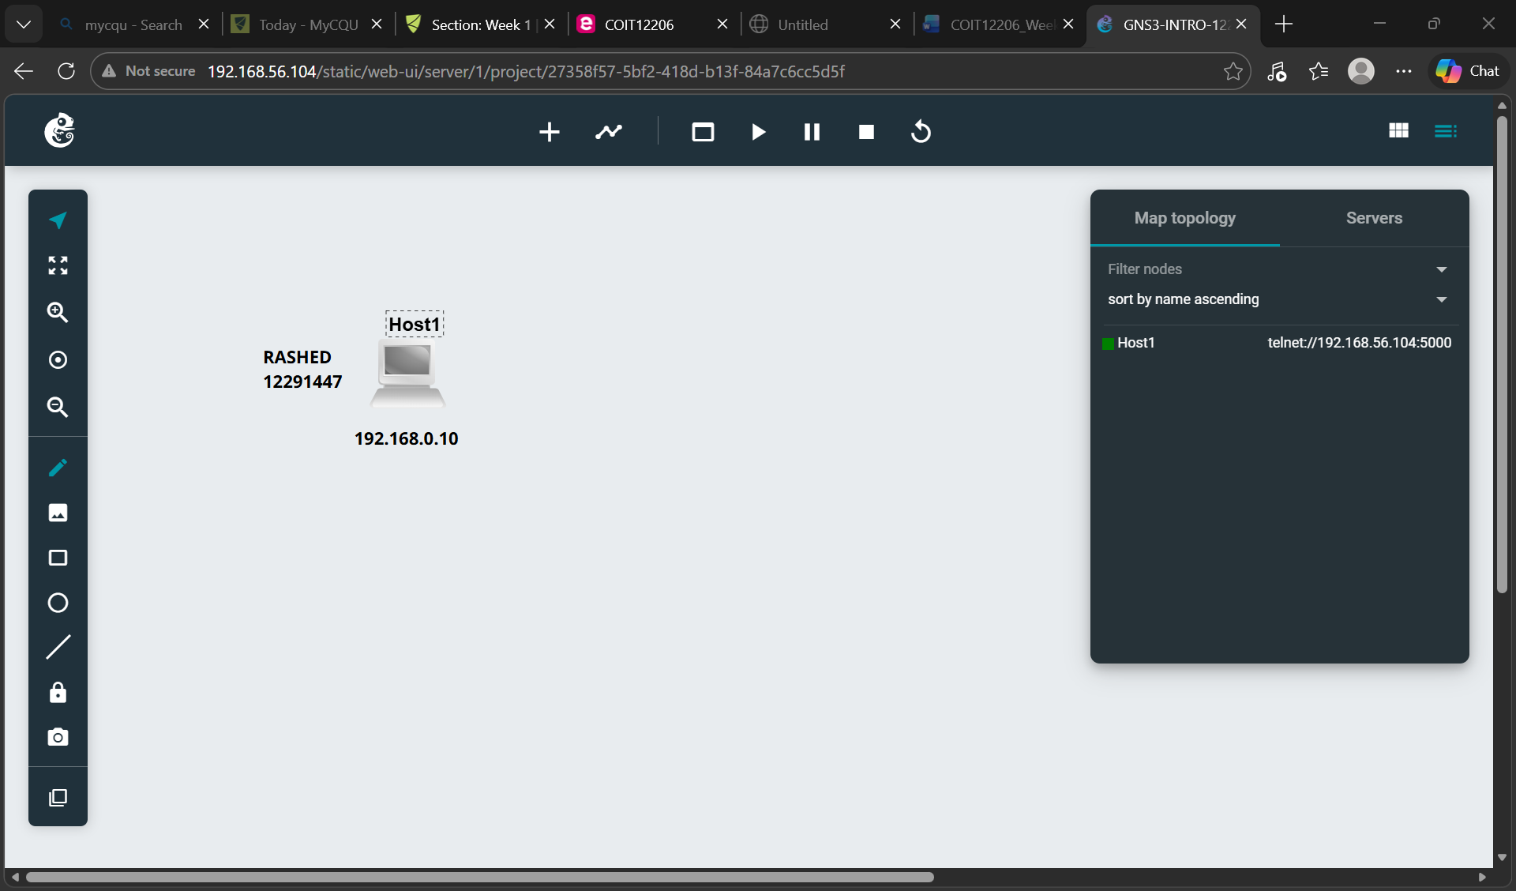

8. Open a web console in a new tab.

9. In the console show your IP address.

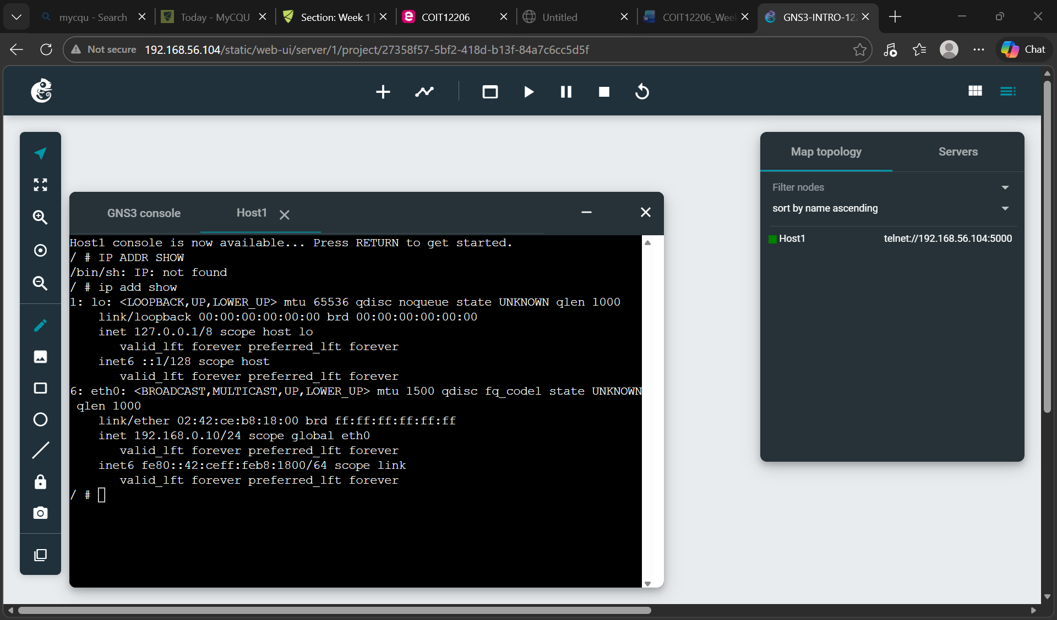

10. Check you have all necessary outputs, made notes of commands you used and learnings, then close the project.

